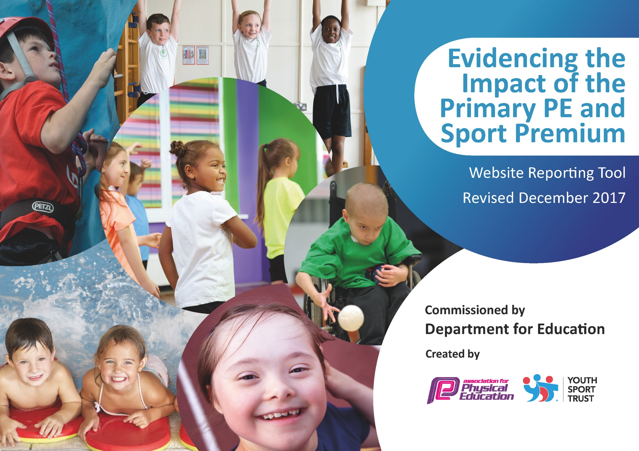

SPORTS PREMIUM ACTION PLAN 2021-22

DRAFT
Key achievements to date: | Areas for further improvement and baseline evidence of need:
Many achievements pre-COVID in terms of successful participation in sporting events, expanding after-school clubs and putting in place a new P.E curriculum. | To re-open up sport in terms of inter and intra-school competition and events, after school clubs and the P.E curriculum.  COVID had the following effect on our planned school sports;  Cancellation of all inter-school and intra-school competition and events.  Cancellation of after-school clubs  Restrictions on the type of sports that could be taught in school.  In a 2021 HRBQ survey, only 41% of children said that they often played running/skipping games and tag at playtime. We need to increase this number.  13% of children said that they don’t find it easy to take part in physical activity at playtime. We need to decrease this number by making sure that all children find it easy to take part in physical activity at playtime.  67% said that they would do more physical activity at playtime if it was fun and enjoyable and 46% said if it was to learn more skills. We need to increase the level of enjoyment and opportunity to learn new skills.

Meeting national curriculum requirements for swimming and water safety | Please complete all of the below*:
What percentage of your current Year 6 cohort swim competently, confidently and proficiently over a distance of at least 25m? | 74%
What percentage of your current Year 6 cohort use a range of strokes effectively [for example, front crawl, backstroke and breaststroke]? | 78%
What percentage of your current Year 6 cohort perform safe self-rescue in different water-based situations? | 48%
Schools can choose to use the Primary PE and Sport Premium to provide additional provision for swimming but this must be for activity over and above the national curriculum requirements. Have you used it in this way? | No

Swimming update

Normally, Y3, Y4 and Y5 children have swimming lessons for one term in each year – giving children the opportunity to practice their swimming in between school lessons. Current Y5 children were not able to go swimming in Y3 or Y4 as they normally would have done. Y5 started swimming lessons in September 2021, but by Christmas not enough children could swim 25m, so the decision was made to continue lessons for the Spring Term.

Action Plan and Budget Tracking

Academic Year: 2021/22 | Total fund allocated: £19,598 | Date Updated:
Key indicator 1: The engagement of all pupils in regular physical activity – Chief Medical Officer guidelines recommend that primary school children undertake at least 30 minutes of physical activity a day in school |  |  |  | Percentage of total allocation:
 |  |  |  | %
School focus with clarity on intended impact on pupils: | Actions to achieve: | Funding allocated: | Evidence and impact: | Note/ Sustainability and suggested next steps:
All children to be physically active in school for 30 minutes each day.  To encourage and promote children to be physically active for at least 30 minutes daily at home. | Every child takes part in two P.E. lessons a week.  After school clubs available for years 1-6.  Encourage children to use exercise log provided on school website.  Skip2bfit workshop and scheme to be followed- daily challenges.  Cancelled due to Covid and lack of communication from Skip2bfit company.  Buy skipping ropes  Playleader training Year 5/6.  Purchase new equipment to encourage physical activity.  After school clubs provided to year 1-6 to promote extra physical activity.  All children to have access to resources and equipment which can be used to create their own games and enhance physical activity levels.  Mr Tinsley to provide training to lead lunch time supervisor on how to play active games and use resources  Purchased MyMove app to increase physical activity at home. | £1200  Booked for 3.2.22  £400 | We will be continuing to provide high quality PE and Sports opportunities during curriculum time, break and lunchtimes, and after school sessions  Regularly check and monitor exercise log and reward children for being physically active.  Children will take part in weekly timed sessions, children’s aim to beat their own score.  Play leaders will ensured all children have accessed outdoor play activities on a daily basis throughout the year. Children to be active throughout their lunch time.  Play equipment ready and available for lunch time use.  Integrate My Move app across school starting with current Year Five next years Year Six children to celebrate and encourage physical activity. Evaluate app and launce next year October half term. | We will be continuing the 30 minute initiative in 22-23. Mi move app will be used rather than the school website.  Playground leaders continuing. In 23-24 Y6 pupils to be trained by Tom Tinsley in the Autumn term.  Lunchtime supervisors take out a box of equipment to play with. An additional £5000 to be spent on playground equipment 22-23 (to include the storage).  .  Repeat 22-23  In use by Y6.  Roll out to Y5 after Christmas  Feb half-term Y3/Y4
Key indicator 2: The profile of PE and sport being raised across the school as a tool for whole school improvement |  |  |  | Percentage of total allocation:
 |  |  |  | %
School focus with clarity on intended impact on pupils: | Actions to achieve: | Funding allocated: | Evidence and impact: | Sustainability and suggested next steps:
Encourage to take on leadership roles within sport.  Profile of sport to be raised through whole school focus days and assemblies and whole school workouts.  Launch whole school initiative (skipping focus). | Sport captains and playground leads to be trained and assigned. To support the delivery of sport and physical activities.  Buy an outdoor speaker (for whole school workouts).  Sport focus week (common wealth games) to include dance workshop.  Skip2bfit workshop to give Staff knowledge and resources on how to increase physical activity through skipping and raise the profile of sport.  Buy skipping ropes for playtimes.  Beginning to establish link with local high school Leasowes with dance and Leasowes school sports day. | £810 for playground leader training  £300  £300  £800  £380 | Booked for March 2022 (Y6) and May 2022 (Y5)  Achieved gold award for Sainsburys schools games mark  Book for w/b 11.7.22  Cancelled – re-booking.  Communicate with Ann Marie Bennett (Leasowes Head of PE). Children to attend more competitions and possibility of sports ambassadors and teachers coming to our school. | See above  Speaker purchased, roll out use in 22-23  Alternative sports week completed during Commonwealth Games.  Continue 22-23

Key indicator 3: Increased confidence, knowledge and skills of all staff in teaching PE and sport |  |  |  | Percentage of total allocation:
 |  |  |  | %
School focus with clarity on intended  impact on pupils: | Actions to achieve: | Funding  allocated: | Evidence and impact: | Sustainability and suggested  next steps:
Develop staff confidence and knowledge working alongside Mr Tinsley (Sports specialist)  Promote sport as a priority.  School to remain in partnership with Dudley school sports network.  Dinner supervisor to organize games after training by TT | Staff audit to be carried out in Spring 1.  PE lead to observe and team teach in PE lessons.  PE lead to mentor a member of staff each half term.  PE lead to provide Inset to support game skills progression.  Subscribe to PE hub to ensure high quality lessons are planned that focus on progressive skills.  All staff to wear PE kit when teaching lessons.  Attend primary PE sports conference summer term  Got cancelled.  TT to attend sport network meeting for PE coordinators. | TLR cost  £3,800  Cover time for TT to complete audit, train dinner supervisor and mentor a member of staff.  £1,100  Dinner supervisor  £2977  Free  Free | Staff to complete audit evaluation after receiving mentoring and team teaching as a result staff knowledge and confidence should improve.
Key indicator 4: Broader experience of a range of sports and activities offered to all pupils |  |  |  | Percentage of total allocation:
 |  |  |  | %
School focus with clarity on intended  impact on pupils: | Actions to achieve: | Funding  allocated: | Evidence and impact: | Sustainability and suggested  next steps:
Children in Reception/Year1 to be able to ride a bike.  All children to take part in an alternative sports week. | Balanceability (Provided by RB Gym and Sport).  Summer term schedule an alternative sports week where children will participate in a wide variety of sports.  Provide INSET for alternative sport week providing staff with teaching strategies and resources. | £5841 | Booked w/b 23.5.22  Booked 11.5.22
Key indicator 5: Increased participation in competitive sport |  |  |  | Percentage of total allocation:
 |  |  |  | %
School focus with clarity on intended  impact on pupils: | Actions to achieve: | Funding  allocated: | Evidence and impact: | Sustainability and suggested  next steps:
Staff availability, transportation to and from sports events will not present a barrier to participation. School will aim to achieve at least silver in school Games Mark.  All children to participate in Inter Competition | Release staff and hire transport to enable children to take part in inter-schools competitions. Pay for entry to relevant competitions. Mr Tinsley to ensure entry to all relevant competitions and to track competitions entered and ensure criteria for school games award.  School sports day (competitive) | £1000 | Cross Country Team – all children ran well. Two pupils came 19th and 20th out of 150 competitors.

